Company description
ISS Governance Home | ISS (issgovernance.com)
CTC: 13 LPA
Criteria: No live ATKT, No Gaps, Min CGPA 8.5
Branches Eligible: BE( CMPN, INFT, EXTC, ETRX)
Date of drive : 22nd July 2022 - (Pre-Placement talk)
25th July 2022 (Technical Test +Technical interview + HR interview)
Entire process was conducted in college, offline.

The selected students were blocked by the company hence they were out of the placement process and cannot go for higher studies for the Academic year 2023-2024

ISS offered 6 different roles; JDs => ISS JDs 2022-23 - Google Drive

I applied for
- General application development
- Software engineer in test automation

Salary breakdown
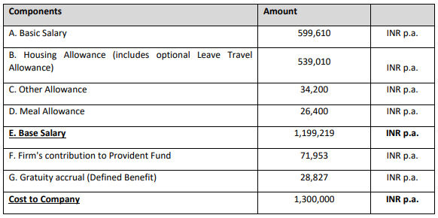

Aptitude
The Aptitude round was quite easy, since this was the first company after JPMC and the entry criteria was not high, there were a lot of applicants. So clearing the aptitude round became difficult, (not because of the difficulty of questions, but because of the high number of applicants).

Aptitude test was conducted in college labs. The round started at ~11:00 am.
Mode of conduction was on google forms
Aptitude consisted of total 70 questions
Aptitude round consisted of 4 sections
- Java
  - Total 18 questions
  - DSA, OOPS, Multithreading
  - Select correct output, find error
  - Other generic questions

- Python
  - Total 17 questions
  - Data structure (list, dictionary…)
  - Select correct output, find error
  - Other generic questions
- SQL
  - Total 5 questions
  - Generating query

- Aptitude
  - Total 30 questions
  - Quants
  - Logical
  - Verbal

Aptitude results were out by ~01:30 pm
Out of 251 applicants, 29 were shortlisted for next round

Technical interview round 1
First technical round started ~02:30 pm
This round was for General application development role
- Basics (OOP, Java, DSA)
- Problem solving
  - Matrix operations -> modifying iterators
  - Reverse linked list -> modifying pointers
- Devops (Kubernetes, Docker)
- Resume overview (Grunt, Kanban, Jira, AWS, web sockets)
- Projects
  - Why?
  - Most challenging part
  - End result
- Extra curricular in technical field (teaching, consultancy)
Interview lasted for approximately 40 minutes
Went over everything written in Resume
I customized my resume based on companies requirements
Most of the interview was around projects and skills that I added in the resume

Technical interview round 2
This round was for Software engineer in test automation role
- Projects
- SDLC
- Testing?
- Questions about testing automation
This round lasted for approximately 30 minutes
Complete interview was based around my past experiences (projects and internships)
Interviewers always ask “Do you have any questions for us” before ending the interview.
ALWAYS ASK QUESTIONS, Question I asked was:
- As a novice in tech industry how beneficial in test automation role as compared to software development or analyst roles that are usually offered

Results were out by 07:00 pm. Out of 29 applicants, 11 were shortlisted

HR round
This was the final round
HR Round started around 08:00 pm

- Introduce yourself
- Tell us something which is not there in your resume
- Hobbies and interests
- Goals
- Future plans
- Strengths and weaknesses
- Some questions regarding Testing automation role
- WHY ISS (why <our company>)

Always prepare these questions beforehand
Make sure to customize the answer as per the companies requirements (do research the company for this, also note informations from pre-placement talks)

ALWAYS ASK QUESTIONS

I asked
- I researched about you ma’am, and I saw that you have been working in this field for over 13 years out of which over 8 years are with ISS, so considering your experience,
How will working with ISS impact me, in my initial phase of working in the tech industry?
- Feedback about my interview

HR round was completed approximately by 09:45 pm
Results were announced in the college itself by 10:30 pm
Out of 11 applicants, all 11 were selected

Additional information

Some of my PERSONAL advices

- Companies coming to our college do not have a high level of requirement, so do not prepare DP, trees, graphs for them. If you are already comfortable with advanced concepts, then it's well and good. Otherwise stick to strong basics and projects
- LUCK plays a big role. So do not get disheartened, because it's not always your fault
- Your job while preparing is to minimize the LUCK factor. How? Work hard.
- Always customize resume and answers to generic questions based on the company and its requirements
- Set a lower limit for yourself, if Salary offered is below that limit, DO NOT apply for that company. This will prevent, you getting blocked by companies giving very less salary as lot of good companies come to college, they are still coming (march 2023)

Resource:
Campus2Corporate 2023 | ISTE-VESIT - Google Docs

